**Dashboard Design**

|  |  |
| --- | --- |
| Date | 20 June 2025 |
| Project Name | Global Energy Trends: A Comprehensive  Analysis of Key Regions and Generation  Modes using Power BI |
| Maximum Marks | 5 Marks |

Creating an effective dashboard involves thoughtful design to ensure that the presented information is clear, relevant, and easily understandable for the intended audience. Here are some key principles and best practices for dashboard design.

**Dashboard 1: Global Energy Trends Through Time**

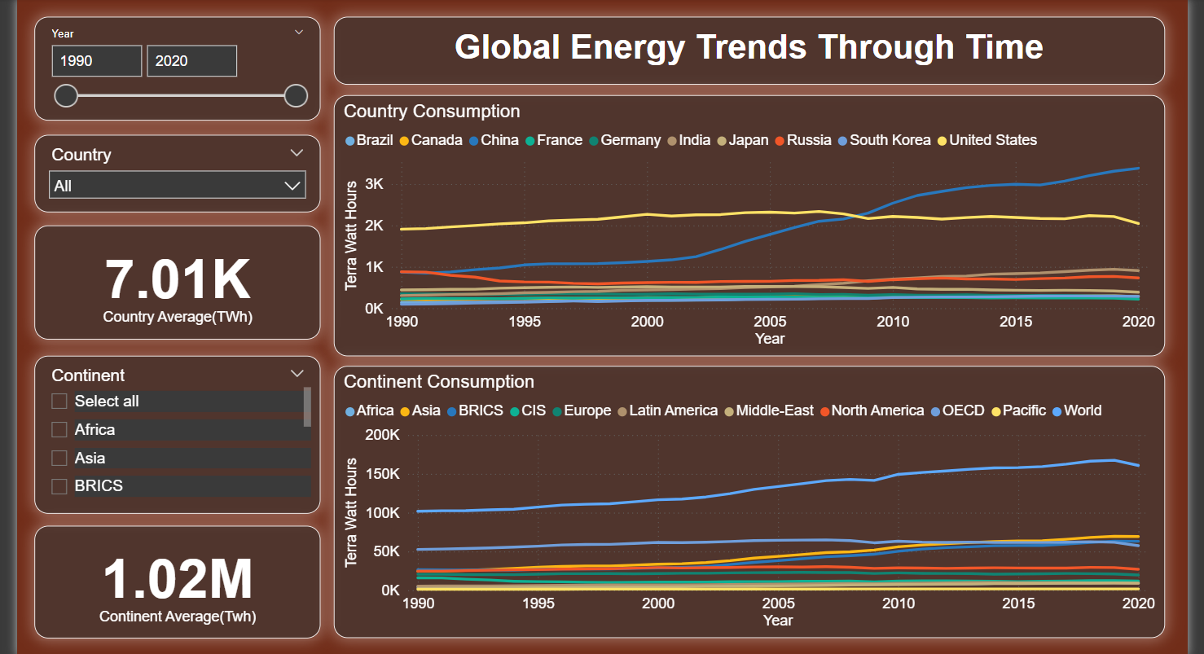

* **Country-Wise Average Consumption**: The average energy consumption per country between 1990–2020 is 7.01K TWh.
* **Continent-Wise Trends**: Continents show an average consumption of 1.02M TWh, with Asia and North America being top consumers.
* **Top Energy Consumers**: The United States, China, and India show consistently high and increasing energy usage trends.
* **China's Surge**: China’s consumption surpassed the US post-2008, showing rapid industrialization and energy demand.
* **OECD vs BRICS**: The OECD countries show stable energy consumption, while BRICS countries show steep growth, particularly post-2000.

**Dashboard 2: Energy Sources**

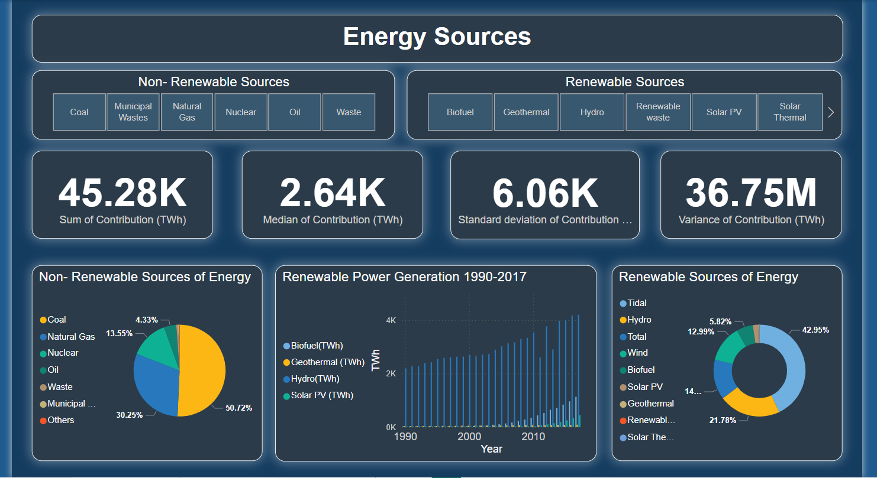

* **Total Non-Renewable Contribution**: Non-renewable sources have a total contribution of 45.28K TWh, showing a heavy global dependency.
* **Renewable Generation Growth**: From 1990 to 2017, renewable power generation has shown consistent growth, particularly in Hydro and Biofuel sectors.
* **Hydropower Leads Renewables**: Hydro contributes 42.95% of total renewable energy, the largest share in the renewable pie chart.
* **Renewables vs Non-Renewables**: Pie charts depict Coal (50.72%) and Natural Gas (30.25%) as the dominant non-renewables.
* **High Variability in Sources**: The standard deviation of contribution is 6.06K TWh, and the variance is 36.75M TWh, indicating wide variation across energy types and countries.

**Dashboard 3: Power Generation – Top 20 Countries**

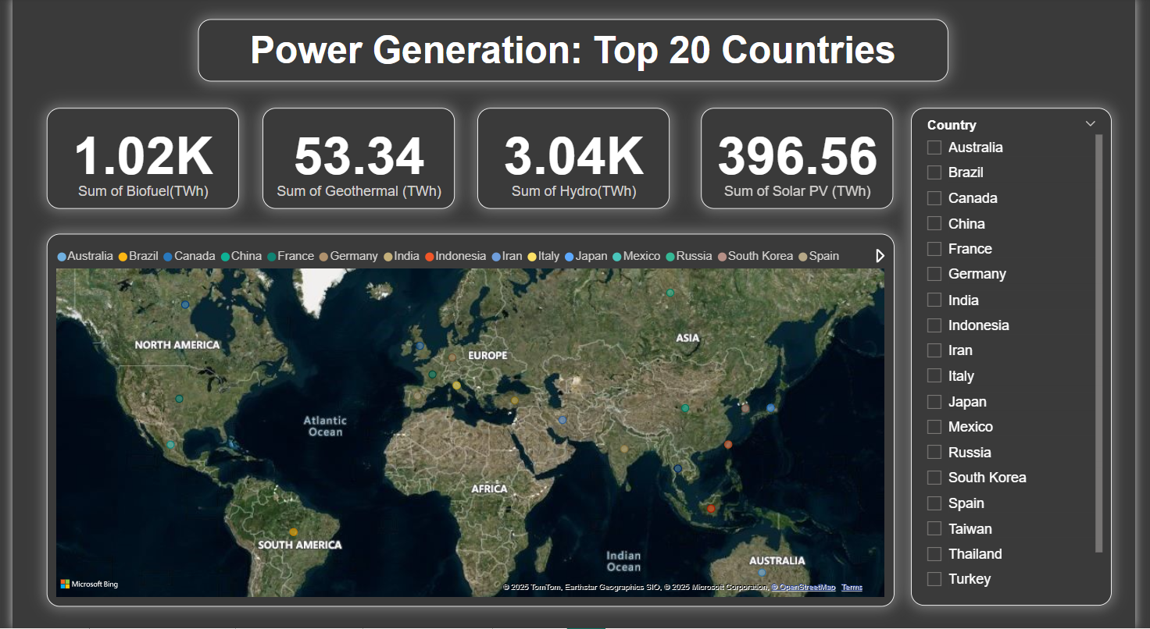

* **Biofuel Contribution**: A total of 1.02K TWh of power is generated from biofuels across the top 20 countries.
* **Hydropower Dominance**: Hydropower leads the renewable sources with 3.04K TWh, showing its critical role in global energy generation.
* **Solar PV Growth**: Solar photovoltaic power contributes 396.56 TWh, indicating significant adoption across various regions.
* **Geothermal Output**: Geothermal energy accounts for 53.34 TWh, which is comparatively lower among renewable types.
* **Geographical Spread**: The world map displays the top 20 countries in renewable energy generation, highlighting China, the US, Brazil, and India as major contributors.